Job Description

JOB TITLE: Advanced Clinical Practitioner
DIVISION: Neonatal Intensive Care unit, Family Health Division
GRADE: 8a
REPORTS TO: Divisional ACP Lead & Head of Service
ACCOUNTABLE TO: Lead Nurse Neonatal & Trust Lead ACP

VALUES AND BEHAVIOURS

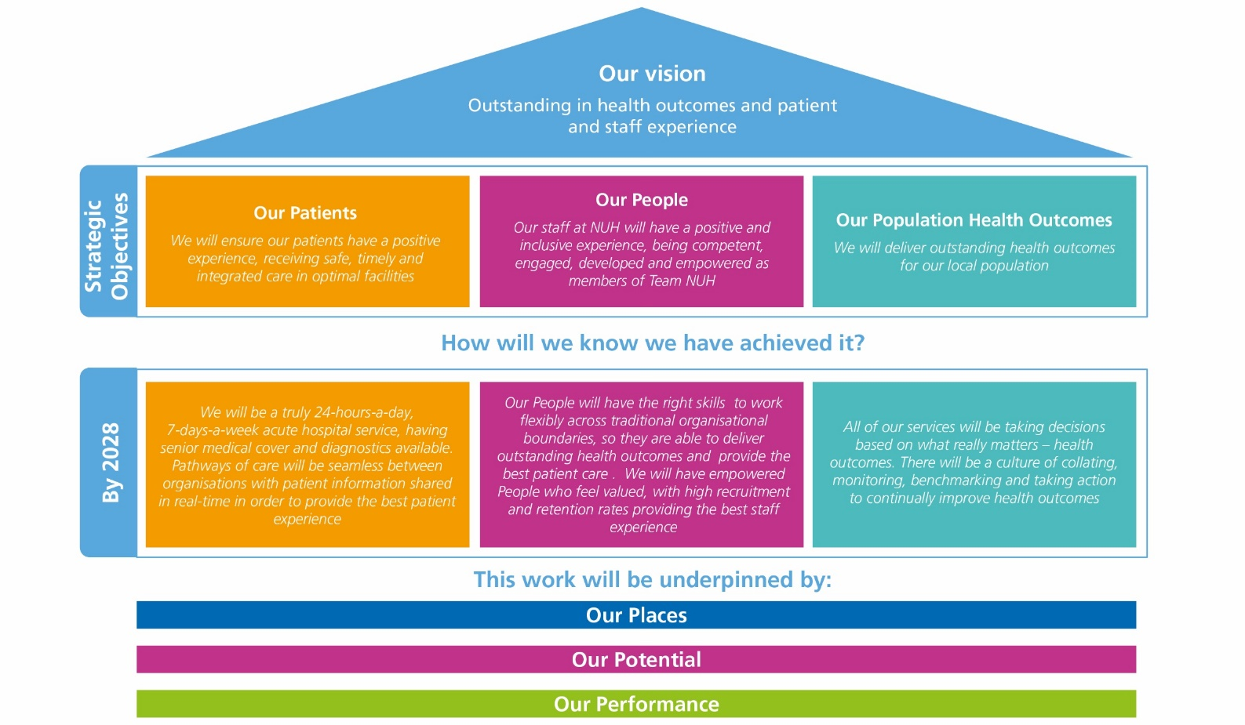

ABOUT NUH

Every day, our teams at Nottingham University Hospitals NHS Trust (NUH) make a difference. We save lives, we improve lives and we usher in new life. We are proud to play a central role in supporting the health and wellbeing of people in Nottingham, Nottinghamshire and our surrounding communities.

With more than 18,000 colleagues, we are the largest employer in Nottinghamshire and one of the biggest and busiest NHS Trusts in the country, serving more than 2.5m residents of Nottingham and Nottinghamshire and a further four million people across the East Midlands and beyond.

We provide a range of national and internationally renowned specialist services and we are at the forefront of new surgical procedures and research programmes.

We are home to the East Midlands Major Trauma Centre, the Nottingham Children's Hospital and in partnership with the University of Nottingham we host a Biomedical Research Centre carrying out vital research into hearing, digestive diseases, respiratory, musculoskeletal disease, mental health and imaging.

As a teaching hospital, we are instrumental in the education and training of doctors, nurses and other healthcare professionals. We are proud of our strong relationships with universities across the East Midlands, including the University of Nottingham, Nottingham Trent University and Loughborough University.

The last year has been challenging for our teams. Alongside our continued recovery from Covid, our maternity services are subject to an independent review and we must do more to improve our culture. We are more focused than ever on making sustained improvements across our services.

As one of the NHS Trusts identified in the New Hospital Programme, a programme of investment in NHS hospitals, we have extensive plans to improve our hospitals and the services we deliver for patients. As well as the redevelopment of the Queen’s Medical Centre and City Hospital, plans for a new 70 bed NHS rehabilitation facility set to be built on the Stanford Hall Rehabilitation Estate near Loughborough, are currently going through the approvals process.

We have recently become home to the latest series of Channel 4’s award-winning series 24 Hours in A&E, which takes a look inside one of the country’s busiest emergency department at QMC and showcases the dedication, passion and skill of our teams.

This is an exciting time to join NUH and help support our future ambitions.

JOB SUMMARY

The post holder will be based at Nottingham University Hospital NHS Trust Neonatal Intensive care Units, working across the Queens Medical Centre and Nottingham City Hospital Site, with the opportunity to participate in Neonatal transport hosted by CenTre Transport service in Castle Donnington.

The Advanced Clinical Practitioner will have specialist knowledge of neonatology underpinned by MSc in Advanced Clinical Practice which includes patient assessment modules and/or hold an NHS England Advanced Practice Digital Badge. We welcome qualified ACP’s who have worked clinically in levels 1, 2 or 3 Neonatal services. They will evidence experience against a Neonatal specific clinical competency framework (BAPM. 2021). The key job responsibilities as described below are divided across the four pillars of advanced practice. We would also welcome applications from newly qualified Neonatal ACP colleagues where a period of supported induction will be ensured prior to completing a VIVA competency assessment. They will be an independent Non-Medical Prescriber registered with the NMC (or equivalent professional body).

The ACP will join a team who perform at different levels of entrustment, sitting alongside tier 1 and tier 2 clinical teams. They will provide neonatal specialist advice, consultancy and clinical practice within the service. The ACP will contribute to the work of tier 1 or 2 rotas, the work pattern of each individual being determined by both their level of experience and competence. They will work across the directorate practicing independently and autonomously with distant consultant supervision.

The ACP will provide clinical leadership and support enabling the coordination of a multi professional seamless service for patients.

The ACP will provide ongoing supervision, education, assessment and support to the speciality. They will play a pivotal role in the operational development of their specialty and their own career development. Their role will include leading, developing and supporting audit and research projects, as well as leading and supporting the development, maintenance and implementation of departmental policies, protocols and guidelines, in line with national guidance and contemporary evidence. Approximately 25% of the ACP role will be dedicated to these non-clinical responsibilities as well as maintaining and developing their professional competence.

The ACP will undertake the role in accordance with Trust and Departmental guidelines but have freedom to act within broad policies and protocols, in accordance with professional responsibilities and boundaries.

KEY JOB RESPONSIBILITIES

Clinical Practice
• To practice in compliance with respective professional code of conduct and within own scope of practice, being responsible and accountable for decisions and actions at this level of practice.
• To take every opportunity to expand individual practice in line with the appropriate professional code of conduct and identifies personal career development pathway as part of formal appraisal system.
• To have a critical understanding of broadened level of responsibility, autonomy and limits of own competence; acts on professional judgment and critical reflection of own practice about when to seek help • To use highly developed clinical knowledge and advanced clinical reasoning skills or decision making skills to independently assess, diagnose, plan, implement and evaluate treatments and interventions for patients, in a context of complex undifferentiated or undefined presentations.
• To undertake physical examination as indicated by the patient’s condition and autonomously analyse complex clinical signs and investigation results to diagnose conditions; consider differential diagnoses; and/or initiate treatment.
• To perform clinical procedures or therapies relevant to the area of practice, as competent to do so, and as appropriate to the history and physical examination of patients, including further invasive testing and treatments requiring highly developed skills and precision.
• To request investigations such as blood, urine and other laboratory tests, electrocardiographs (ECGs), ultrasound scans, X-Rays, magnetic resonance imaging (MRI) and computed tomography (CT) scans in accordance with IR(ME)R regulations and as local policy allows.
• To analyse multiple sources of information (including patient history, physical examination and investigation findings) to make evidence-based diagnoses and/or clinical judgements; presenting this information to senior ACP colleagues or medical staff for advice when scope of practice is exceeded.
• To autonomously formulate appropriate management plans for patients, formulates clinical decisions and often complex intervention plans to manage acute illness and acute episodes of chronic illness.
• To continuously revaluate findings and clinical response to intervention and establish appropriate ongoing management plan accordingly, including referral, admission or discharge from service.
• To utilise and demonstrate effective and sensitive communication styles, anticipating and working to overcome potential barriers to communication, to support people in making informed decisions.
• To create a trusting partnership with patients and/or relatives/carers to communicate complex medical issues (including new diagnoses) to ensure service users are fully informed and consent to intervention and management plans.
• To prioritise health problems and intervenes appropriately in complex, urgent and emergency situations, including initiation and leadership of resuscitation.
• To appropriately manage risk, especially where there may be complex and unpredictable events, to ensure safety of individuals, families and carers.
• To prescribe and review medication (as an independent prescriber) for therapeutic effectiveness appropriate to patient need and in accordance with best/evidence-based practice and national and local protocols and within the role’s scope of practice and legal framework. Integrates both pharmacological and non-pharmacological treatment in patient care/management plans.
• To maintain competence in the use of electronic prescribing and medication administration (EMPA) and has completed a combined scope of practice and prescribing agreement signed by ACPs head of service/divisional medical lead, matron/divisional lead nurse and the specialty pharmacist.
• To assesses patients with mental health needs using local policy and guidelines and refer to the appropriate services.
• To assess mental capacity, gain valid consent and have to ability to work within a legal framework with patients who lack capacity to consent to treatment on behalf of their dependants.
• To identify and intervene proactively when circumstances contribute to an unsafe environment for patients, staff, or relatives and escalate these to the departmental risk lead and/or consultant leads for clinical governance; Support specialty management with risk assessments, DATIX and complaints as appropriate
• To produce detailed and accurate written information within the patient record regarding all clinical assessments, investigations completed and requested, and treatments administered.
• To maintain the responsibility for the delivery of a detailed, accurate and potentially complex clinical handover to healthcare colleagues including other specialties, external organisations and General Practitioners.
• To maintain confidentiality as required by professional, local, and national policy; acknowledging situations where there can be a breach of confidentiality
• To work towards accreditation with relevant clinical governing body e.g., centre for advanced practice, BAPM, RCEM (Royal College of Emergency Medicine), FICM (Faculty of Intensive Care Medicine) or equivalent internal tailored programmes, if the option is available to do so.
• To maintain a personalised e-portfolio that demonstrates competence, capability, and ongoing development.

Leadership and Management
• To proactively develop effective partnerships with the existing senior medical, nursing and AHP teams, to encourage productive working in driving new practice and service redesign; acts as a knowledge resource in how to initiate development and manage change.
• To lead in multi-disciplinary service and team evaluation, demonstrating the impact of advanced clinical practice on service function and effectiveness and the quality (i.e., outcome of care, experience, and safety).
• To formulate and implement the co-production of service improvements in response to peer review of own and other’s practice; feedback and involvement from service users (individuals, families, carers, communities), working across boundaries with a broadened sphere of influence.
• To act as a resource for staff, advising on local, organisational and national policy, procedures and guidelines; Engaging in horizon scanning for future developments (e.g. new treatments, changing social challenges) to develop practice in response to changing population health needs.
• To highlight and address areas of witnessed poor practice and demonstrate a preparedness to constructively challenge others, appropriately escalating concerns that affects an individual’s safety and well-being (patient/family/carer/colleague).
• To manage conflicting views and liaises between groups where there may be conflict. To rrecognize and defuse potentially aggressive and violent individuals or situations in line with local policy and legal frameworks.
• To manage staff performance, training, and supervision of other staff including annual Trust appraisal and annual review of clinical practice (ARCP).
• To support staff development to maximize potential, encouraging everyone to learn from each other and from external good practice.
• To support patients, carers and staff during difficult situations that arise e.g., breaking unwelcome news or following an unexpected event.
• To develop and contribute to local guidelines, interpreting and adapting national protocols and standards to enhance patient care and safety.
• To maintain awareness of budgetary constraints within the organisation, manages resources appropriately and encourages others to do the likewise.
• To ensure appropriate representation and participation in organisational meetings as appropriate for the role.
• To prioritise workload to support and manage the surges in demand across the clinical hospital and organisation in accordance with Trust pressures.
• To contribute to recruitment and retention of MDT staff.
• To engage in the development of meaningful partnerships from local to international level in order to deliver a collaborative approach to advanced clinical practice

Facilitating Learning
• To critically asses own learning needs and identify a personal development plan that reflects breadth of professional development across the four pillars of advanced practice.
• To engage in self-directed learning, critically thinking to maximise clinical skills, knowledge and ability to lead and develop care and services.
• To develop health promotion and education in conjunction with other health care professionals ensuring that all patient care within the multi-professional team is based on research and best practice.
• To empower individuals to participate in decision about their care by supporting health literacy and providing support and clinical advice in specialist areas, based on evidenced-based research.
• To advocate for and contribute to a culture of organisational learning; Supporting and delivering education programmes and training pathways for multi-professional learners across NUH.
• To act as a role model, educator, supervisor, coach and mentor, identifying and supporting the developmental needs of individuals and the wider team.

Evidence, Research and Development
• Critically engage in research activity, e.g. design, coordinate, and undertake collaborative audit and research, to develop and apply evidenced-based practices within Neonates.
• To undertake Service Improvement methodology training, e.g. Quality Service Improvement Redesign (QSIR)
• To evaluate own and others’ clinical practice with valid, reliable methods, and the act on findings.
• To lead on or actively collaborate in a minimum of annual audit / quality improvement as evidenced by inclusion in their e-portfolio and outputs; Disseminate best practice findings and quality improvement projects appropriately to underpin own practice and inform that of others.
• To complete Good Clinical Practice Training (GCP).
• To engage in research activity at a minimum of patient selection when required.
• To contribute towards and/or lead on the development of multidisciplinary research and clinical audit implementing evidence-based practice; Critically review and identify gaps in the evidence and its application to practice, alerting appropriate individuals to these gaps and how to safely and pragmatically address them.
• Facilitates collaborative links between clinical practice and research supporting organisational and system research and development plans.
• To proactively engage in the improvement of the department by enhancing levels of evidence-based practice and the development of guidelines and protocols to ensure high standards of care are consistently maintained.

GENERAL DUTIES
In addition to the key job responsibilities detailed in this job description all employees at Nottingham University Hospitals NHS Trust are expected to comply with the general duties detailed below:
Infection Control
To maintain a clean, safe environment, ensuring adherence to the Trust’s standards of cleanliness, hygiene and infection control.

For senior/clinical managers the following statement must also be included
The post holder is accountable for minimising the risks of infections and for the implementation of the Code of Practice for the Prevention and Control of Healthcare Associated Infections as outlined in the Health Act 2006. This includes receiving assurance of risk and embedding evidence based practice into daily routines of all staff.

Safeguarding children, young people and vulnerable adults
Nottingham University Hospitals is committed to safeguarding and promoting the welfare of children, young people and vulnerable adults. All staff and volunteers are therefore expected to behave in such a way that supports this commitment.

Information Governance
All staff have an individual responsibility for creating accurate records of their work and for making entries into and managing all NHS records effectively in line with the Health Record Keeping Policy and other Health Records and Corporate Records Management policies and procedures in order to meet the Trust’s legal, regulatory and accountability requirements.

Health and Safety
To take reasonable care to prevent injury to themselves or others who may be affected by their acts or omissions.

To co-operate fully in discharging the Trust policies and procedures with regard to health and safety matters.

To immediately report to their manager any shortcomings in health and safety procedures and practice.

To report any accidents or dangerous incidents to their immediate manager and safety representative as early as possible and submit a completed accident/incident form.

To use protective clothing and equipment where provided.

Whilst the aim of the Trust is to promote a co-operative and constructive view of health and safety concerns in the organisation, all staff must be aware that a wilful or irresponsible disregard for safety matters may give rise to disciplinary proceedings.

Governance
To actively participate in governance activities to ensure that the highest standards of care and business conduct are achieved.

Health and Wellbeing
Employees are expected to take all reasonable steps to look after both their physical health and mental health. To support employees to achieve this NUH offers a wide range of health and wellbeing activities and interventions. The full programme can be viewed at on the staff intranet.

Line managers are expected to encourage and support staff to look after their health and wellbeing, including the release of staff to attend health and wellbeing activities and interventions.

General Policies Procedures and Practices
To comply with all Trust policies, procedures and practices and to be responsible for keeping up to date with any changes to these.

WORKING CONDITIONS
Describe the post holder’s normal working conditions (such as exposures to hazards, requirement for physical effort etc).

JOB REVISION
This job description should be regarded as a guide to the duties required and is not definitive or restrictive in any way. The duties of the post may be varied from time to time in response to changing circumstances. This job description does not form part of the contract of employment.

Service Review
A strategic review of all Trust services is taking place, as a result of which some services, or parts of some services, may transfer from one campus to the other. This will be decided in accordance with the most appropriate way to provide the best healthcare for patients in the future and all staff will be fully consulted on about the impact of any such decisions.

Job description reviewed by:
Date:

